**Unit 4 Quiz 1 PRACTICE QUIZ** Name: Quang Huynh

Quiz 1 will be worth 17 points. It will cover Topics 1-2 so before you start this practice quiz, make sure you have done those assignments (and topic checkpoints!) AND CHECKED YOUR ANSWERS!! It will consist of mostly short answer type questions and focus mostly on phase changes and particle attractions.

1 1.) According to the melting point data on Table S, the element with the strongest attractions between atoms is

(1) Na – sodium (3) Rb – rubidium

(2) K – potassium (4) Cs – cesium

2.) You are given a sample of compound “XY”, as shown below.













**XY XY XY**

**YX YX YX**

A student says that XY’s high melting point means that there is a weak attraction

between the elements X and Y in one particle of XY. Explain why this is incorrect.

This is incorrect because the higher the melting point is in a compound or element, the stronger the

attraction be. Same goes for if the melting point is low, then the attraction would be weak. So since

XY has a high melting point, it would mean that it has a strong attraction.

3.) Is fusion an exothermic or endothermic process? Explain your decision.

Fusion would be an endothermic process because it takes heat and energy in, absorbing it to perform it.

4.) a.) Sketch a heating curve below.

Gas



Temperature



Heat absorbed

b.) Label the graph where “Heat of Fusion” (Hf) and “Heat of Vaporization” (Hv) are absorbed.

c.) *There are many other parts to a heating curve that can be labeled as well. If you feel you need to review this, please fill in the other parts on your diagram above (ie – phases, phase changes, PE constant vs. changing, KE constant vs. changing, etc.).*

5.) Base your answers on the information in the table to the right. Explain in terms of attractions why Substance D has a low melting point.

|  |  |
| --- | --- |
| Substance | Melting Point  (°C) |
| A | 10 |
| B | -150 |
| C | 852 |
| D | -267 |
| E | 625 |

Substance D would have a weak attraction due to the low melting

point. A lower melting point would mean less energy is used,

thus, a lower attraction happens.

6.) Use the heating curves below to fill in the following chart. Both curves represent a constant heating starting with each substance in the solid state.

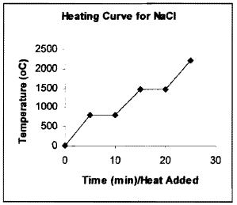

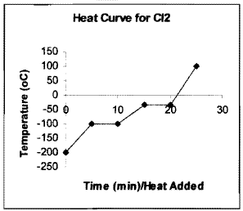

|  |  |  |
| --- | --- | --- |
|  | **NaCl** | **Cl2** |
| **Type of bond present** | Ionic | Covalent |
| **Lewis Structure** |  |  |
| **Phase at STP** | Aqueous | Gas |
| **Melting Point** | 800oC | -100oC |
| **Boiling Point** | 1,500oC | -50oC |

7.) If 3.4 moles of NaCl was heated, how many grams would you have measured out?

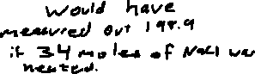

We would have measured out 198.9 grams if 3.4 moles of NaCl was heated.